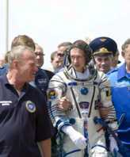
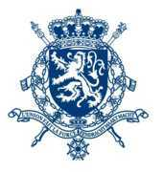
KINGDOM OF BELGIUM

Federal Public Service
Foreign Affairs,
Foreign Trade and Development Cooperation
Belgium Unlimited
Culture
Science

News from Belgium

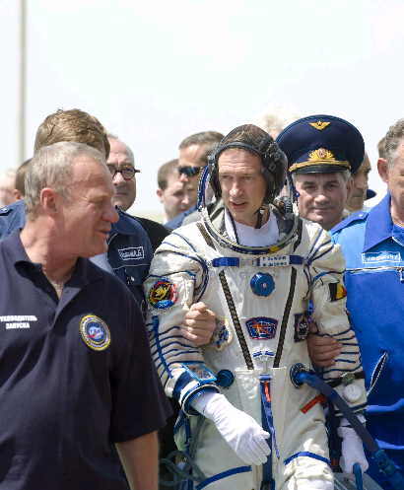
Belgium on the
international stage
The economy & business
Miscellaneous
- Belgian astronaut Frank De Winne ready to depart to the ISS
N°4 / May - June 2009
Miscellaneous
Local news
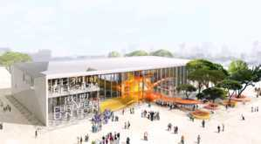
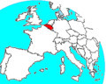
- Launch of the Belgian pavilion at the Shanghai World Expo 2010

In May 2010, the new Universal Exposition will open its doors in Shanghai. China expects 70 million visitors at the World Expo 2010 with the theme « Better City, Better Life ».

On June 3, 2009, a ceremony was organised in Shanghai in order to launch the Belgian pavilion. This was the occasion to present the concept and design of the pavilion.

The Belgian pavilion will have a surface of about 5.250 m². It will be built in an area dedicated to European pavilions and will also host the exposition hall of the European Union.

The pavilion is created around the structure of a « Brain Cell », the dominant conceptual image for the building. It evokes the artistic richness of Belgium and Europe as well as its scientific achievements which contribute to the development and enrichment of our cultural and intellectual heritage. The Brain Cell also refers directly to the role of Belgium as one of Europe’s main gathering centres and crossroads of three great cultural traditions: Latin, Germanic and Anglo-Saxon.

In contrast to the playful, organic and intriguing shape of the Brain Cell, the exterior of the building refers to the pragmatism and the discretion typical of Belgium.

The changing lights and colours of the Brain Cell will naturally be integrated in Shanghai, “city of lights”. The multitude of visual effects in the pavilion echoes the European Clair-Obscur movement and the Chinese shadow theatre which will be visible from the main public spaces in front of the pavilion.

Belgium is a unique place within Europe where different cultures, races and beliefs cohabit, travel and meet. The pavilion wishes to combine this diversity of cultures in a balanced way. This unique combination on a relatively small territory has made Belgium a fertile and creative country, rich in resources and driven by a spirit of openness and tolerance.

http://www.shanghaiexpo2010.be/

Belgium on the international stage
- Peter Van den Bossche appointed as one of the seven members of the Dispute Settlement Body of the World Trade Organisation (WTO)

On June 19, 2009, Belgium’s Peter Van den Bossche was appointed in Geneva as one of seven members of the Dispute Settlement Body (DSB) of the World Trade Organisation (WTO). The DSB is the highest body for settling global trade disputes.
Professor Van den Bossche was appointed to represent the EU after a broad consultation process with the WTO member countries. He was actively supported by the European Commission throughout the campaign stage. Van den Bossche will take up his renewable four-year mandate on December 12, 2009.
Van den Bossche’s pro-development outlook and his in-depth knowledge of international trade law, of WTO institutions, and of the settlement of international economic disputes were all crucial factors in landing him this prestigious job. Other factors that secured him the job included his image as an independent-minded, impartial and collegial person and also his personal enthusiasm.

http://www.diplomatie.be

Scale-model of the Belgian pavilion © Conix Architects
- Belgium Unlimited -

- Belgium, together with France, will lead the European Union Battle Group II/09

The concept of the European Union Battle Group (EUBG) fits in the overall efforts of the European Union to develop a rapidly deployable military capacity, which it can use to intervene in conflict zones. A Battle Group (BG) is available for orders within the full spectrum of crisis management operations: humanitarian and rescue tasks, peacekeeping tasks, and tasks of combat forces in the area of crisis management, including the establishment of peace, but also disarmament and aid to countries at the occurrence of terrorist threats. Any decision on the deployment of a battle group should be taken only after a thorough analysis of the situation, and requires the approval of all EU member states.

The EUBG concept envisages that every six months two battle groups will be ready to be deployed in a radius of 6,000 km around Brussels. Each BG has at its disposal at least 1,500 troops who (after a decision process of up to 5 days) can be ready to be deployed within 5 to 10 days. Each BG is autonomous for at least 30 days, which can be extended to four months pending any necessary re-provisioning requirements.

More than 20 Member States participate in the development of these battle groups. It should also be noted that some countries that are not part of the EU, such as e.g. Norway, also participate. In 2010, Turkey will participate too.

Belgium, together with France, is expected to participate in EUBG II/09 in the second half of 2009 by contributing approximately 1,500 soldiers, besides which it will take command by setting up a deployable operational headquarters. The Force Commander is staff colonel Jean-Paul Deconinck. At each EUBG II/09 level one can recognize next to any Belgian contribution, several requisite French elements also. Luxembourg contributes by making a water purification unit available to the BG.

The battle group has readied itself for this through mid-2009. The proper functioning of an operational headquarters is only possible by using modern communications tools and providing a fully formed and motivated staff.

http://www.mil.be

The Belgian mine-sweeper Lobelia takes part in a multinational mine clearing operation in the Baltic Sea

The Belgian mine-sweeper Lobelia has taken part in the multinational mine clearing operation MCOPLIT 09 in the Baltic Sea.

On board of the mine-sweeper, 38 soldiers participated from 8-24 May, 2009, in the detection and destruction of sea mines and other explosive gear in the territorial waters and exclusive economic zone of Latvia. Not just Belgium took part in the operation. Germans, French, Lithuanians, Estonians, Latvians, Danes and Poles also joined the operation with their ships, totaling eight nationalities.

The Belgian mine-sweepers have taken part in multinational mine clearing operations in Estonia, Latvia and Lithuania annually since 1998. Belgium has established a sizable expertise in the clearing of mines off the Baltic coast, training of the Baltic States Navies and their integration into NATO.

http://www.mil.be

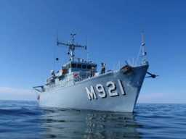
© Defence
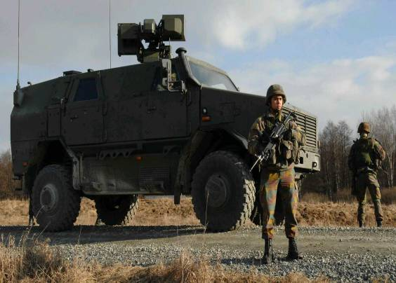
© Defence
Culture
- Opening of the Hergé Museum in Louvain-la-Neuve

Over the years, Hergé’s artistic output has gained recognition as an important body of work. The idea of a museum, open to the public and exhibiting his numerous and diverse creations, was first discussed in 1979. A lot of thought and time has been put into developing the concept for such an ambitious project.

The Fondation Hergé was created in 1986, three years after Hergé’s death. This institution, which has since been renamed Studios Hergé, has never stopped identifying and cataloguing the elements that would one day make up the fabric of a museum specially dedicated to Hergé.

On 10 January 2001, the anniversary of the first appearance of Tintin, an important announcement was made: construction of the Hergé Museum would begin in Louvain-la-Neuve, less than 30 kilometres from the Belgian capital, Brussels. Eight years later, the dream has become real. The Hergé Museum opened its doors on June 2, 2009, two years after the first stone was laid on 22 May 2007, the 100th anniversary of the artist’s birth.

It was worth the wait. A famous architect, Christian de Portzamparc from France, was selected to bring these incredible plans to fruition. He had won the 1994 Pritzker Prize, the most prestigious and coveted international architecture award. He has a profound understanding of the graphical elements of Hergé’s work, and has exemplified the primary artistic facets of the pioneer of the ‘Clear Line’ in his design.

http://www.museeherge.com/

- The Ommegang (Brussels, 30 June & 2 July 2009)

On the first Thursday of July and the previous Tuesday every summer, the Ommegang lights up the magnificent of Brussels. The Ommegang is a theatrical representation of an event that took place in 1549 in the honour of Emperor Charles V, accompanied by his son Philip, Crown Prince of Spain and Duke of Brabant. The glorious and majestic procession in Brussels with more than 1400 costumed performers helps relive a historical time. The pageant winds its way on foot and on horse, flying banners and pennants, in a colourful but solemn token to the opulence of the Renaissance city on display for all to see.

This majestic pageant strides along the proud façades that once housed the guilds and the elegant architecture of the Town Hall, one of the handsomest gothic monuments in Belgium.

http://www.ommegang.be

© Hergé – Moulinsart 2009
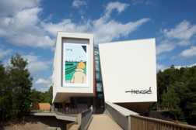
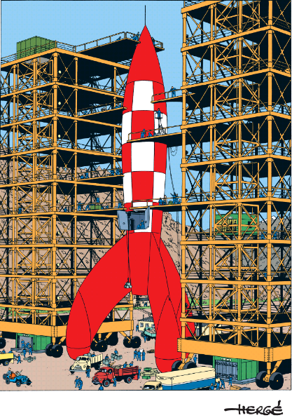

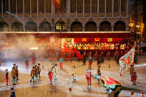
© Nicolas Borel. Atelier de Portzamparc 2009
© Louis-Philippe Breydel
- The Cats Parade ("Kattenstoet") of Ieper

On May 10, 2009 the Cats Parade of Ieper took place. The Cats Parade is a rare - and at first glance cruel - folkloric relic of old Germanic practices. From the end of the 12thcentury until 1817, live cats were cast off the belfry tower.

This was done to symbolically slay the evil spirits, which were personified by the cat. Today, every three years on the second Sunday in May, the city jester throws velvet toy kittens down the belfry tower. The highlight of the program is the festive Cats Parade, in which dozens of floats and two thousand extras depict the role of the cat in history, literature, the vernacular and folklore.

http://www.ieper.be/ieper_en.aspx?SGREF=13725

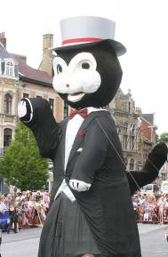
- 15th edition of the Queen Elisabeth International violin competition (4 – 30 May 2009)
The Queen Elisabeth Competition was established in 1937. At the time it was known as the Eugène Ysaÿe Competition. H.M. Queen Elisabeth and the celebrated Belgian violinist and composer were behind this magnificent project. The first edition took place thanks to the financial support offered by the de Launoit family and a number of personalities from the Belgian artistic and economic worlds. It was not until after the war, in 1951, that the Queen Elisabeth Competition really came into being.
The Queen Elisabeth Competition is open to musicians who have already completed their training and who are ready to launch their international careers. The competition covers the following musical disciplines: piano, voice, violin and composition. The performance sessions take place every three years and the competition for composers before each instrumental session. The winning works of the composer's competition are given as compulsory works during the piano and violin sessions.
This years edition (4 – 30 May 2009) of the Competition was the 15th to be devoted to the violin, Queen Elisabeth’s favourite instrument. It has allowed us to discover a new generation of young violinists. This year’s laureates will, we are sure, be added to the list of great names who have been laureates of the Queen Elisabeth Competition in the past: Leonid Kogan, Jaime Laredo, Gidon Kremer, Yuzuko Horigome, Vadim Repin, Nikolaj Znaider, Baiba Skride, and Sergey Khachatryan, among others.
The preselection round, which was held behind closed doors, determined which candidates were admitted to the public rounds of the Competition. The 24 violinists who performed in the semi-final were each accompanied by Paul Goodwin and the Orchestre Royal de Chambre de Wallonie in a Mozart concerto, while Gilbert Varga and the National Orchestra of Belgium joined the finalists in the Brussels Centre for Fine Arts.
This year, the compulsory work in the semi-final was commissioned from Claude Ledoux. It was the prestigious jury of the International Composition Competition, however, that chose the unpublished work performed in the final, with the orchestra (“Agens” by the Korean composer Cho Eun-Hwa). The other works chosen by the candidates had to meet certain criteria of style and era decided by the Artistic Committee.
On May 31st, the chairman of the jury announced the 6 laureates of this year’s competition:
First prize: Ray Chen (Australia)
Second prize: Lorenzo Gatto (Belgium)
Third prize: Ilian Garnet (Moldavia)
Fourth prize: Kim Suyoen (South Korea)
Fifth prize: Nikita Borisoglebsky (Russia)
Sixth prize: Yoon Soyoung (South Korea)
The remaining 6 finalists do not receive a ranking.
As every year, master classes were given by some members of the jury, whose talent should make for fascinating encounters. Starting in June, concerts given by the laureates offered many more great musical moments. Moreover, a 3-CD box set is now available.

- Luc Tuymans, “Against the day”(Wiels, Brussels, 23 April - 2 August 2009)

This first solo show of Luc Tuymans in Brussels presents, in world premiere, twenty new paintings which he created especially for Wiels, the Centre for Contemporary Art.

The works can be seen as the third and last part of a triptych that began with the series Les Revenants about the power of the Jesuit Order and continued with Forever. The Management of Magic, about the Disney phenomenon. In this new series, Tuymans continues his work focusing on television-reality shows, which manipulated images and illusions he examines through his painting practice.

http://www.wiels.org/site2/dbfiles/mfile/900/944/PF_Luc_Tuymans.pdf

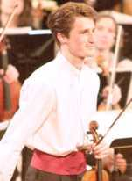

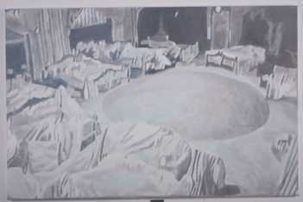

Luc Tuymans Big Brother,
2008 Oil on canvas 146 x 224 cm
Courtesy : David Zwirner, New York and Zeno X Gallery, Antwerp

http://www.cmireb.be/
- Opening of the new Musée Magritte Museum in Brussels

On June 2nd, 2009 the new Musée Magritte Museum opened its doors in Brussels.

The museum holds the world’s richest collection devoted to the Belgian surrealist artist.
More than 250 works await the visitor: oils on canvas, gouaches, drawings, sculptures and painted objects, as well as advertising posters, musical scores, vintage photographs and films shot by Magritte himself. The Musée Magritte Museum will be THE world reference centre for knowledge about the artist. It houses a research centre that allows access to archives on the life and work of the painter.

The new museum is the result of a partnership between the Royal Museums of Fine Arts of Belgium and the Fondation Magritte. It benefits from the indispensable backing of GDF Suez and the Régie des Bâtiments.

The Empire of Light, 1954 © Charly Herscovici, with his kind authorization – c/o SABAM-ADAGP, 2009-

http://www.musee-magritte-museum.be/
http://www.magritte.be/
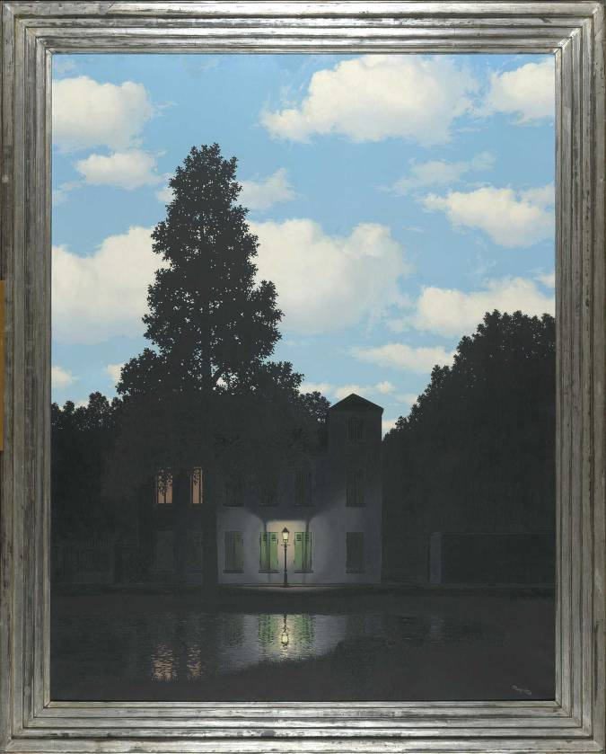

- Kunstenfestivaldesarts 2009 (Brussels, 30 April – 23 May 2009)

When the Kunstenfestivaldesarts became part of the fabric of Brussels for a period of three weeks, it opened up an “alternative” space and time for those willing to take up the challenge.

The festival presented some thirty new works by international artists, a series of daring and fascinating pieces which are remarkable for their formal originality as well as for the relevance of what they have to tell us – a carefully composed range of works, then, but not necessarily harmonious, and certainly not monotonous. Through performances, installations and films from around the world, the Kunstenfestivaldesarts aims to record the world we live in.

The Kunstenfestivaldesarts wants to avoid set thematic guidelines or clearly defined aesthetic precepts. Its aim, rather, is to trigger correspondences, to facilitate exchanges between works and people wishing to encounter new ideas. The festival stands for openness and curiosity about what artists have to tell us, and, as a result, what they might reveal about the world and how to live in it.

These projects were shown in some twenty theatres, cultural centres and public spaces throughout the city.

http://www.kfda.be

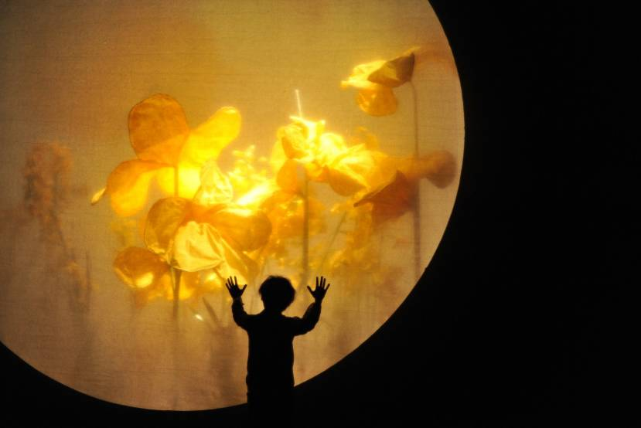
© Academie Anderlecht – Almudena Crespo
- europalia.china: enjoy four months of Chinese culture in the heart of Europe (Oct. 8, 2009 - Feb. 14, 2010)

Every two years Europalia, one of the largest art and cultural festivals of Europe, presents the cultural heritage of a host country. For 4 months an impressive series of exhibitions and shows present an as close to complete as possible picture of the cultural richness of the host country. Europalia organizes this festival in collaboration with major museums and cultural centers in Brussels, Belgium but also in neighboring countries.

On the occasion of its 40th birthday, Europalia dedicates her festival to the culture of one of the most fascinating countries, CHINA. The idea for the creation of europalia.china arose during a meeting of HM King Albert II and President Hu Jintao, on the occasion of the Belgian King’s state visit to China in June 2005.

From 8 October, 2009 to 14 February, 2010 europalia.china will present the masterpieces of Chinese history, but also the contemporary art scene. Some 50 exhibitions and 400 performances - music, opera, theater, dance, film, literature - were divided into 4 main themes: Immortal China, Contemporary China, Colorful China, China and the world.

© Tang Ya – Météore

http://www.europalia.eu
Since more than 2 years Europalia has worked together with the Ministry of Culture of the People's Republic of China and its unique network of local partners. In China, 19 provinces, cities and independent regions, 58 museums, libraries and archaeological institutes participate in the festival. At europalia.china, a total of more than 1,000 Chinese artists are given stage time.

In Belgium and Europe Europalia works together with a committee of leading experts and 210 cultural partners in 75 cities and 5 countries.

© Tang Ya - Meteor
http://www.europalia.eu



At the same time, the Rockox House will be scheduling the exhibition Gifts of God. Private patronage of the Antwerp churches during the sixteenth and seventeenth century. Both exhibitions complement one another beautifully and bear testimony to the splendid talent available in Antwerp at the time and of its economic important for the city's development.

http://www.dekathedraal.be

Quinten Metsijs, Lamentation of Christ, 1500-1511
© Royal Museum of Fine Arts Antwerp
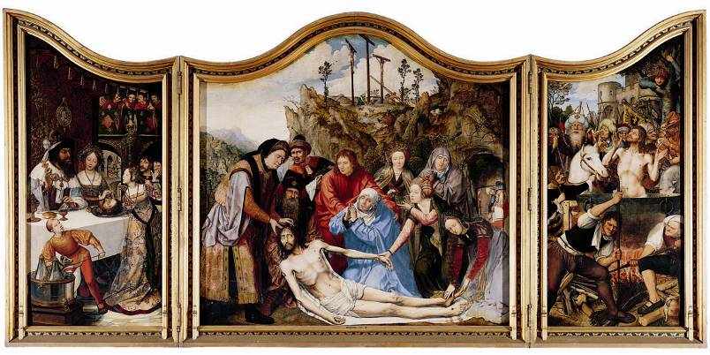
- Exhibition “REUNION. From Quinten Metsijs to Peter Paul Rubens. Masterpieces from the Royal Museum reunited in the Cathedral” (Antwerp, 5 June - 15 November 2009)

In 1559, the Church of Our Lady was re-baptized the Cathedral of Our Lady. During its 450-year existence, the Cathedral has become a veritable treasury of religious art, which was painted and sculpted by renowned masters. Until the French Revolution, they were commissioned with decorating the pillars, chapels and walls of the Cathedral. In the wake of this upheaval, several altarpieces were transferred to museums.

Eight of the most beautiful altarpieces are being returned to the Cathedral. The Cathedral will also showcase eight works that are featured in its permanent collection. These are mostly imposing works, mainly triptychs, measuring up to 5 metres wide and 3 metres high. These works will be integrated in the cathedral's current interior. This unique “in situ” reunion will give visitors a spectacular overview of masterpieces created by the Antwerp school during the Golden Age.

Dr Ria Fabri and Dr Nico Van Hout, who are the curators of his exhibition, will provide an insight into the guilds’ and brotherhoods’ patronage of the cathedral by means of the altarpieces on display. Visitors will thus be able to re-discover the interwoven nature of society, religion, art and culture during the sixteenth and seventeenth centuries. The exhibition also sheds light on the iconographical and social-economic developments over the centuries.


Science
- Belgian astronaut leaves on Soyuz rocket to the International Space Station ISS

Belgian astronaut Frank De Winne departed on May 27, 2009 into space from the Russian launch site Baikonur in Kazakhstan by means of a Soyuz rocket. De Winne is being sent on this mission by Esa. He is part of the permanent astronaut corps of the European Space Agency, and has been selected by the Esa board for this important mission.

Except for Frank De Winne there were two other astronauts on board: Roman Romanenko (Russia) and Robert Thirsk (Canada). Two days after their launch, the three astronauts arrived at the International Space Station ISS, where they joined three colleagues who were already present. De Winne will remain there for six months, to return to earth by the end of November 2009. Furthermore, from late September on, he will for two months be board commander of the international space complex. This is a first, because so far, the commanders of the space station have always been Russians or Americans.
The crew of the ISS will be mainly occupying their time during their mission by integrating new components in the space station and maintaining the operational integrity of all equipment; it is the first time it is being occupied by six permanent crew members. In addition, the astronauts are charged with performing science experiments.
http://www.belgiuminspace.be
http://www.esa.int/esa-mmg/mmg.pl?topic=&subtopic=&keyword=oasiss
http://scienceconnection.be

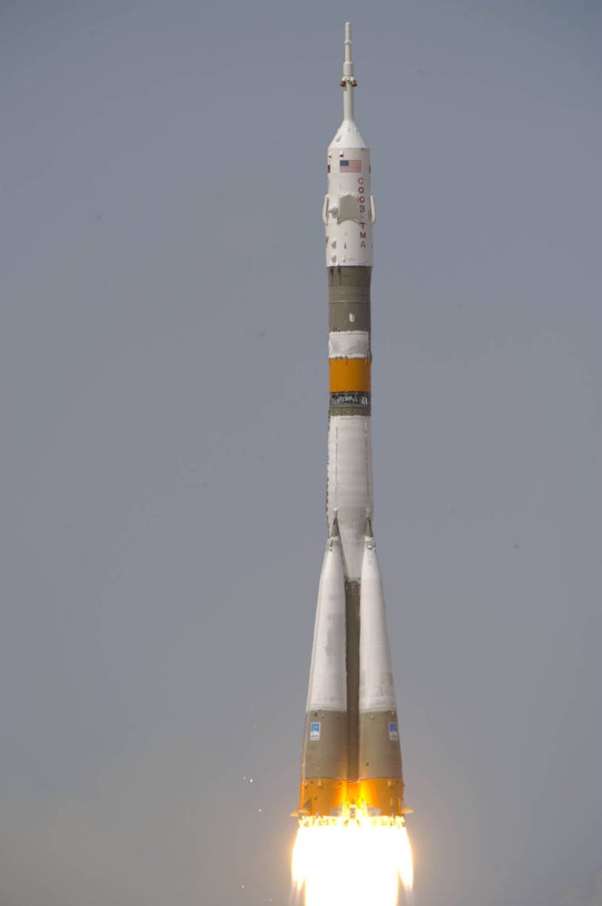

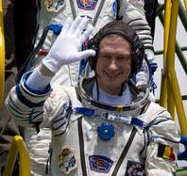
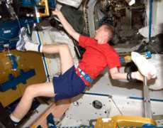
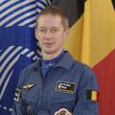
© ESA - S. Corvaja, 2009
© ESA - GCTC, 2009
© ESA/NASA

- Launch of pioneering brain research

IMEC, Europe’s leading independent nanoelectronics research center, VIB, Flanders’ leading life science institute, and the Leuven University, K.U.Leuven, set up a joint basic research initiative to unravel the neuronal circuitry of the human brain: Neuro Electronics Research Flanders (NERF). Supported by the Flemish Government, NERF will look into fundamental neuroscientific questions through interdisciplinary research combining nanoelectronics with neurobiology. It intends to push the boundaries of science, by zooming in on the working of neurons at an unprecedented level of detail. In the long run, NERF will generate new insights in the functional mapping of the brain, as well as research methodologies and technologies for medical applications, i.e. diagnostics and treatment of disorders of the central and peripheral nervous system.

NERF will officially take off on October 29, 2009. By 2014, NERF aims to expand its team to about 50 international top-researchers.

http://docs.vlaanderen.be/portaal/beleidsbrieven2008-2009/Ceysens_Economie_Ondernemen_Wetenschap_Innovatie_en_Buitenlandse_Handel.pdf
http://www.imec.be

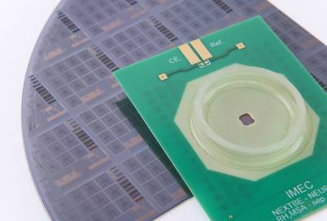
© IMEC Packaged chip for in-vitro measurement of neuron activity

- Hieroglyphics on DVD at the Université Catholique de Louvain

The UCL provides a world premiere. Claude Obsomer, professor at the Institut d’orientalisme at the UCL (Université catholique de Louvain) has developed an educational DVD to study old Egyptian language.

The DVD contains information regarding the pronunciation, writing, words, phrases, but also photographs, animation and interactivity. It helps students and individuals who want to learn or perfect their skills of this ancient language.
The DVD allows users to learn the old, classical language, as well as learn or deepen their knowledge of Egyptian hieroglyphics. The DVD can be used to support lesson plans, but also just as-is, by individuals. The DVD is quite complete in content and deals with the grammar, the vocabulary, writing and translation of the ancient Egyptian language.

The following teaching parameters were used to make the DVD as user-friendly and operationally useful as possible:

- each word can also be listened to so that the user may learn the correct pronunciation
- Each hieroglyph is linked to an image and/or educational animation. This allows for easier hieroglyph analysis and reproduction
- many photos taken at archaeological sites make it possible to place hieroglyphics in their proper context

The DVD is available from publisher Safran.

http://www.uclouvain.be/ and http://www.safran.be

- Leuven astronomers achieve breakthrough in research on red giant stars

An international team led by Joris De Ridder of the Institute of Astronomy of the Catholic University of Leuven (KUL) has, for the first time, unambiguously discovered non-radial vibrations in red giant stars.

Red giants are stars that are in a late phase of their lives. In that stage stars strongly expand, causing their outer layers to cool, which gives them a red hue. Simultaneously their core contracts, rendering its density to become huge: more than 1,000 times the density of gold. Astronomers are interested in red giants because they represent a future picture of our own Sun. Moreover, some uncertainties in the theory about the inner constitution and life path of stars are better studied by learning about red giants than younger stars.

The best way to get a good understanding of a star is by "listening" to its vibrations. Such vibrations, also called oscillations, can be studied by observing tiny changes in the brightness of the star. It turns out that there are two types of vibrations: non-radial and radial oscillations. Non-radial oscillations reveal much more information about stellar interiors than radial ones.

Using ultra-precise measurements of brightness variations by the CoRoT satellite, researchers were for the first time able to unambiguously determine non-radial oscillations in red giants. Using these vibrations they can now probe the insides of these stars. The discovery therefore opens up new perspectives to study the interior of stars in a late stage of their life. This will allows us to better understand how our Sun will eventually end its life. The research results were published in Nature (article: Non-radial oscillation modes with long life times in giant stars, Nature, 2009, Vol. 459, p. 398).

http://www.nature.com/nature/journal/v459/n7245/pdf/nature08022.pdf
http://www.ster.kuleuven.be/~joris/backgroundInfo_en.pdf

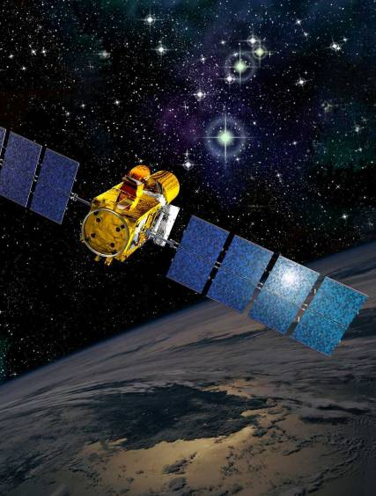
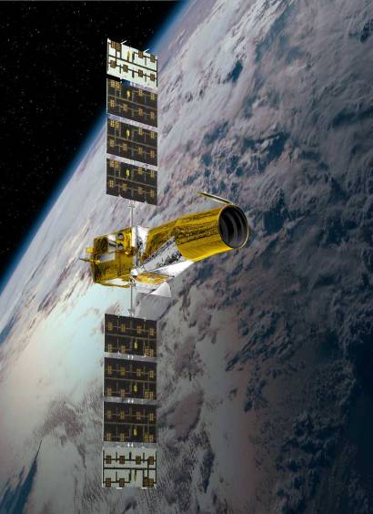
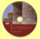
© Safran
The CoRoT Satellite, © CNES


- Belgian Professor wins Medicine International Paulo Gontijo Award

On June 19 2009, in São Paulo (Brazil), Prof. Dr. Peter Carmeliet, a Belgian researcher, won the 2nd Medicine International Paulo Gontijo Award, with his study named “Novel role for VEGF Receptor-1 and VEGF-B in Motor Neuron Degeneration”. The research was published last October 2008 as an article in The Journal of Neuroscience and it investigates the VEGF-B protein (Factor B of Vascular Endothelial Growth) neuroprotective function.

Since VEGF protein acts in the vascularization of areas where the motor neurons are located, some studies have suggested that the protein participates in the modulation of neurodegeneration. Dr. Carmeliet focused on these evidences, mainly on the action of VEGF-B variant in the death of motor neurons – because they have a low performance in the angiogenesis (formation of new blood vessels).

Dr. Carmeliet proved that VEGF-B is a neuroprotective factor when he applied it in rats with SOD 1 gene mutation – one of the ALS causes.The protein gave higher survival to rats with no side effects. The scientist also tried in vitro experiments and got similar results. “This study proves that the animal model can be modulated. It is another way to alleviate the disease clinical characteristics, very safely”, Miguel Mitne Neto, a biologist and doctorate candidate in genetics from Human Genome Center, in Universidade de São Paulo, states.

Peter Carmeliet is PHD in Higher Education in Medicine at University of Leuven. Recognized with more than 40 awards and tributes, Dr. Carmeliet has taught in different courses and institutions such as University of Leuven, Brussels and Harvard. Currently, he is the director of VIB Neurovascular Department at the Vesalius Research Center of the University of Leuven (Katholieke Universiteit Leuven).

Belgium attaches the utmost importance to scientific research and aims at promoting international co-operation between research institutions. Academic and scientific exchanges constitute one of the main priorities of our country.

http://www.kuleuven.be/cv/u0021003.htm
http://www.ipg.org.br/home.php

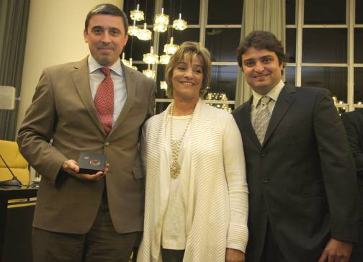

Professor Carmeliet (left)

- US biopharmaceutical company Genzyme invests in new bioreactor in Geel

US biopharmaceutical company Genzyme announced plans to further expand its hi-tech cell culture production facility in Geel (province of Antwerp). An additional bioreactor will increase production of the revolutionary medicine Myozyme, used for the treatment of Pompe disease, a rare condition causing progressive muscle weakness and leading to paralysis of the patient. Myozyme is the only medicine able to stabilize patients.

Genzyme is one of the world’s leading biotechnology companies, with 11,000 employees in locations spanning the globe. The total investment in Geel amounts to EUR 46 million.

Genzyme estimates that the new reactor will start production in mid-2011. The new bioreactor will be the third at the Geel biomanufacturing plant and will meet growing demand for the drug.

http://www.genzyme.be/docs/Genzbe_050709_en.pdf

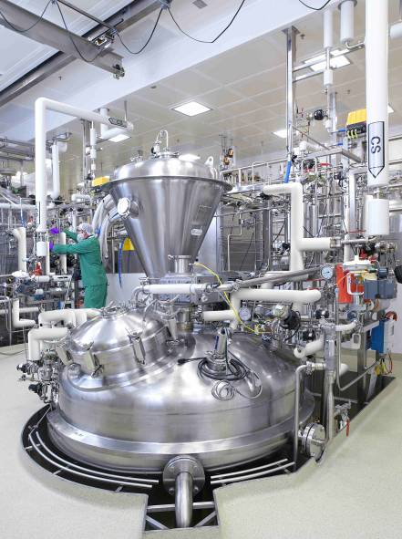
© Genzyme geel – production bioreactor
The economy & business
- Belgian company signs major contract for the treatment of wastewater for the city of Bagdad

The wastewater of the Iraqi capital will soon be treated thanks to Belgian wastewater treatment technology. The company Waterleau, with headquarters in Herent (Leuven, in the province of Vlaams-Brabant), signed a contract for the construction of 15 wastewater treatment installations with a total installed capacity of 1,350,000 population equivalent. The contract has a value of € 22 million. All the equipment has to be shipped to Bagdad before the end of the year.

Since ten years, Waterleau has been active worldwide in the design, engineering, construction and operation of environmental installations and solutions. This encompasses not only wastewater management, but also air treatment, waste treatment and production of drinking water and renewable energy.
http://www.waterleau.com/

- Port of Antwerp launches unique trial project with shore power for seagoing ships

The port of Antwerp has taken an important step in the fight against port-related air pollution. The Antwerp Port Authority, the Flemish Community and Independent Maritime Terminal have initiated a trial project making it possible for seagoing ships to use a shore-based electricity supply when they are lying at berth. As a consequence they will no longer have to run their polluting onboard engines to generate power. The environmental impact of this investment is direct, local and significant as regards i.a. emissions of NOx, CO2 and particulates. The Port Authority attaches great importance to this project, as shore power is an integral part of its approach towards combating air pollution on a local scale and also contributes to combating the greenhouse effect.

Shore power is already available for barges, pleasure craft, as well as the Port Authority’s tug and dredger fleet, floating cranes and dry dock complex. Soon it will also be supplied to houseboats. Until now, however, it had not been available to seagoing ships, the segment which in view of its size has the most powerful effect on environmental performance.

This project is a world first: it is unique not only in terms of the amount of power that has to be generated but also in terms of the types of ships served as well as the technical facilities needed.

http://www.portofantwerp.com/portal/page/portal/POA_EN

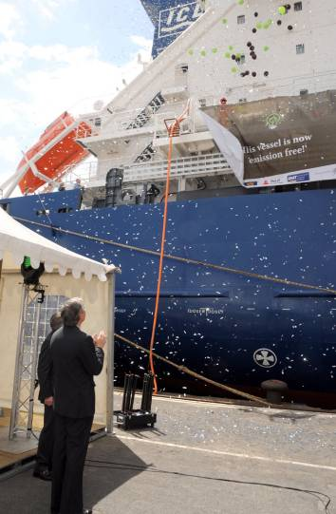

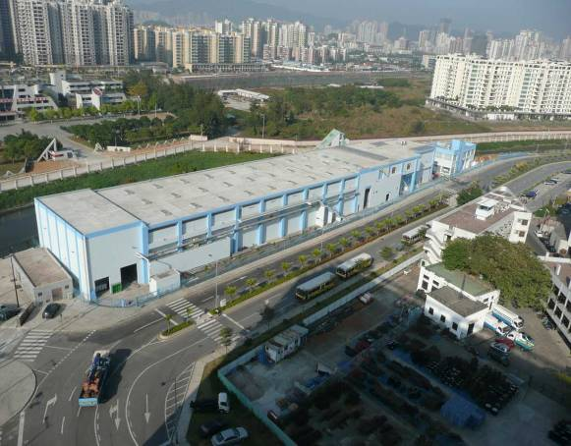

© Antwerp Port Authority

© Waterleau

- For the first time ever, Charleroi Airport welcomes more than 300,000 passengers a month
Brussels South Charleroi airport (BSCA) processed more than 300,000 passengers in April 2009, which is a growth of 29% compared to April 2008. The growth is largely due to an increase in the number of destinations and frequencies from the airport. During the first quarter of 2009, BSCA processed more than 1 million passengers. This is 20% more than the same period a year earlier.

http://www.charleroi-airport.com/doc.php?nd=o29&tid=29&lg=1&docid=1&site=1

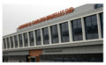

© bsca charleroi-airport

- Thales Alenia Space is to equip the next 35 Ariane 5 rockets

Thales Alenia Space ETCA from Charleroi is the largest manufacturer of space electronics in Belgium, Europe's leader in the provision of electrical power for satellites, and #1 supplier of electronics for Ariane 5. The company also supplies the Russian Soyuz, and likewise is specialized in the telecom and security sectors. Thales Alenia Space has a second subsidiary in Belgium, specifically Thales Alenia Space Antwerp in Hoboken. This branch specializes in satellite transmissions.

Thales Alenia Space ETCA has delivered parts to Arianespace since the 1970s. Thus far the company has 1,150 deliveries under its belt.

Recently Thales Alenia Space ETCA signed a contract with the company Astrium for the supply of electronic components and services for the Ariane 5 rockets, which will be launched between 2011 and 2015. This is the largest contract the company has ever signed.

At the same time Thales Alenia Space ETCA will be responsible for the maintenance and operation of the control and command systems and information technology for the launch of the next Arianes 5.

http://www.thalesonline.com/space/index.html

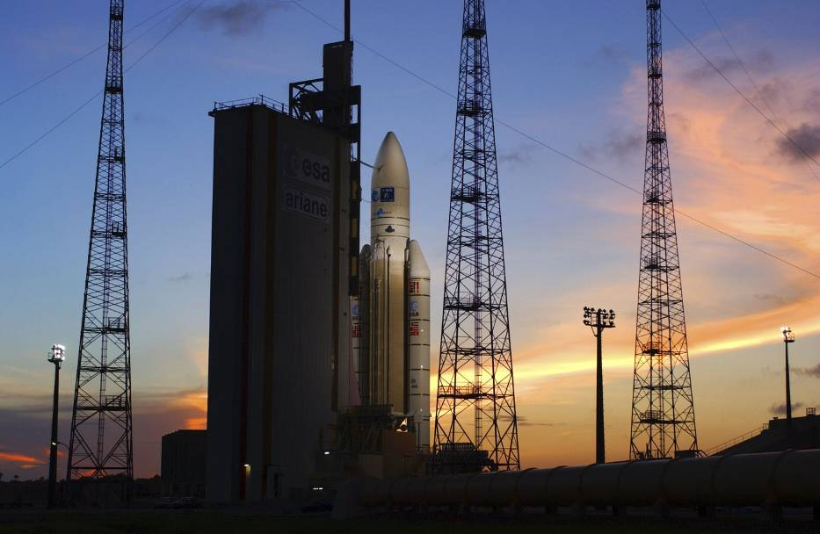

© Arianespace, ESA, CNES

- Port of Zeebrugge signs partnership with South Korea

The port of Zeebrugge has signed a cooperation agreement with the South Korean coastal port Pyeongtaek. The two ports which are very comparable in terms of infrastructure, port sector and strategy, will include information sharing and joint organization of seminars and commercial contacts. Zeebrugge is very interested in the thriving South Korean car market. Last year 600,000 cars were shipped from Pyeongtaek. Zeebrugge is the world leader in this segment with more than 2 million new vehicles.

http://www.zeebruggeport.be/

- Belgian chemical industry spends record amount on Research & Development
The Belgian chemical and life sciences companies have invested a record amount of € 2.34 billion in research and development in 2008. According to Essenscia, the umbrella organization for businesses in the chemical sector, the research and development expenditures have more than doubled in ten years, from € 1.13 billion in 1998 to 2.34 billion in 2008.
The economic crisis that broke out during the last quarter had no negative impact on the constant increase in the budgets for innovation.
© essenscia
( http://investinbiopharma.be)

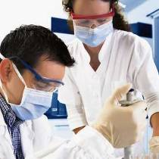
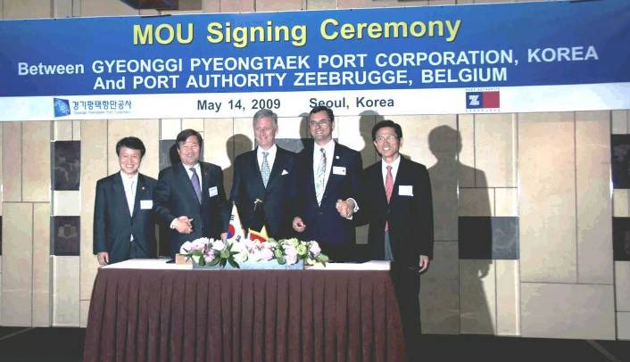

Miscellaneous

- A new brochure about Belgium

A new general brochure about Belgium, "Belgium at a glance", has been published and is intended for a wide foreign audience. In 32 pages, the reader gets, in text and image, a concise explanation of our country. The classic brochure ingredients are present, including geography, history, government structure, economy and industry, science, architecture, arts and culture, gastronomy, fashion, sports, folklore, and Belgium and Brussels in the world. Some actual informative numbers and a list of FAQs, "Did you know that ...?," round off the brochure.

“Belgium at a glance” is available in a number of languages. One can also view the electronic version on the websites of Belgian embassies and consulates.

- eID crossed the Belgian borders

On June 4, 2009 the first Belgians living abroad received their new electronic identity card (eID) at the Belgian Consulate General in Lille.

Thusfar, the eIDs were reserved for Belgians residing in Belgium, but now the eID program is being gradually extended through 120 other consulates and embassies abroad, where they will replace the current non-electronic identity cards of 265,000 Belgians 18 years or older living abroad.

The eID is an example of administrative simplification efforts. Belgians living abroad will, due to the eID, be able to receive certain administrative documents directly to their homes, without needing to go to their embassy or consulate, often hundreds or even thousands of kilometers from their place of residence.

Each year as many as 30,000 new cards are issued throughout the world. In this way Belgium opens the way for new technological applications of e-government, and allows for Belgian expertise and know-how to be advertised abroad.

http://welcome-to-e-belgium.be

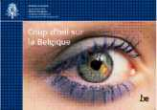

- Belgium placed 15th on list of most peace-loving nations in the world

Belgium is placed 15th on the world peace-index of Global Peace Index 2009, an initiative of the Institute for Economics and Peace. This index ranks 144 countries according to their peace level determined on the basis of 23 indicators, including military expenditures, relationships with neighboring countries, respect for human rights, level of democracy and education, etc. The indicators were set by an international panel of experts. The 2009 Index shows that things are getting increasingly worse when it comes to peace in the world. The cause can be found in an increase in the number of armed conflicts in certain countries, and the currently raging worldwide recession.

http://www.visionofhumanity.org/gpi/home.php



- Brussels Airport, 1st European airport to put “green touchdowns” to the test
Brussels Airport is to see the start of the so-called environmentally-friendly landings using the continuous descent approach (CDA).
The CDA method is part of a test project in line with the European plan to make air traffic more fuel friendly, emit less CO2 and reduce noise pollution.
What sets the CDA apart from the “traditional” touchdown is the earlier descent from a higher altitude, resulting in a more gradual landing and less acceleration. With the CDA approach, the pilot starts the landing procedure about 50 kilometres before reaching the airport and allows the aircraft to gradually descend in a continuous motion.
An environmentally-friendly landing saves 50 to 150 litres of fuel per flight and reduces CO2 emissions by 160 to 470 kilogram. An added bonus is the reduction of noise in residential areas around the airport.
http://www.investinbrussels.com

- Elections on June 7, 2009

Belgians proceeded to the ballot boxes on Sunday, June 7, 2009 to elect their representatives in the European Parliament, the Flemish Parliament, Walloon Parliament, the Brussels-Capital Parliament and the Parliament of the German-speaking community.

The Parliament of the French community is not elected directly, but consists of 75 members of the Walloon Parliament and 19 French-speaking members of the Parliament of the Brussels-Capital Region.

The results of the European elections led to the following composition in representation: Open VLD, PS en CD&V each have 3 seats ; SP.A, Vlaams Belang, ECOLO, MR en CDH each have 2 seats ; Lijst Dedecker, GROEN! en N-VA each have 1 seat.

In the Flemish Region CD & V is the largest party, but the N-VA reported the most significant gains.

In the Walloon region the PS remains the largest party, but the big winner was ECOLO.

In the Brussels-Capital Region the MR is the largest party, but there too the big winner was ECOLO.

In the German-speaking community CSP remains the largest party, but ECOLO was the strongest gainer.

For the complete election results:

http://polling2009.belgium.be/en/
http://elections2009.belgium.be/fr/
http://verkiezingen2009.belgium.be/nl/

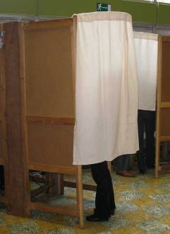

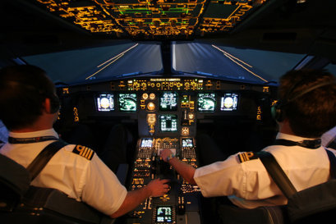

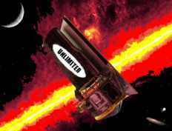

© Bussels Airlines

belgium o bElGiUm o belgium

- Belgian cartoonist Mehdi Boualam wins major European Commission-sponsored cartoon competition

The European Commission had asked young graphic artists to create a cartoon that shows what it means to be citizens of a united Europe. Over 2,500 young people ages 16 and older gave ear to the call.

After the completion of the first national selection process, three winners were announced on May 11, 2009. Mehdi Boualam from Belgium was chosen as the best of the competition. In the cartoon, Boualam outlines a European life without borders; a man who is born in France, educated in Spain, gets married in Germany, and eventually settles in Italy.

The best cartoons can be viewed at http://www.eurocartoon.eu. They will also be used for future awareness campaigns on European citizenship.

http://www.secteurpublic.fr/public/article/%C2%ABunion-europeenne-et-citoyennete%C2%BB-les-laureats-europeens-du-concours-de-bande-dessinee-ont-ete-designes.html?id=18069&rub=8283&C5

Belgium expands its European lead for social expenditures

Figures from Eurostat, the Statistical Office of the EU, show that the 27 EU Member States in 2006 averaged 26.9% of their gross domestic product (GDP) being on social welfare spending. Eurostat describes social spending as social security, housing and minimum subsistence levels. In 2006 Belgium spent 30.1% of its GDP on social expenditures. Moreover, the percentage increased in Belgium compared to 2005 (29.7%), despite strong economic growth in 2006, and the fact that in good economic times usually the need for social protection decreases.

http://epp.eurostat.ec.europa.eu/cache/ITY_PUBLIC/3-02062009-BP/EN/3-02062009-BP-EN.PDF

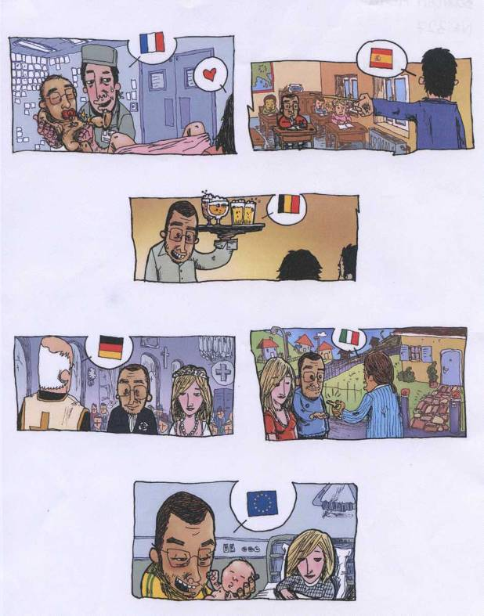
© European Commission &
Mehdi Boualam

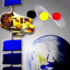



FPS Foreign Affairs, Foreign Trade and Development Cooperation

Communication Department
Rue des Petits Carmes 15
1000 Bruxelles
Belgium
Tel. + 32 2 501 81 11

The details contained in this publication are for information only; the FPS shall not be held liable by law for any details contained herein.
This Newsletter is protected under Belgian and international copyright law.

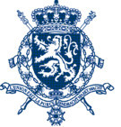
www.diplomatie.be
www.dgcd.be
www.belgium.be
www.invest.belgium.be

Agenda
- Music festivals that brighten the summer

Traditionally during the summer months a wide range of music festivals take place throughout Belgium. In various outdoor locations one can enjoy music from home and abroad. Thousands of music lovers will find something of their liking, since all categories are covered. Often, these summer music events are accompanied by festive sideshows. The list of festivals is very long. Some examples: Couleur Café, Brosella Folk & Jazz, Jazz Bilzen, Jazz Middelheim, Gent Jazz Festival, Sfinks, Pukkelpop, Dranouter Folkfestival, Graspop, Suikerrock, Gentse Feesten, Zomer van Antwerpen, Lokerse Feesten, BeLEUVENissen, Marktrock, Maanrock, Les Ardentes, Dour, Les Francofolies, Esperanzah!, Verdur Rock, Octopus Rock etc.

The most famous music festival in Belgium is undoubtedly Rock Werchter, which in 2008 at the International Live Music Conference in London for the 4th out of 5 years was declared the best rock festival in the world.

Also, the Festival de Wallonie and the Fête de la Musique annually attract thousands of visitors.

http://www.festivals.be
http://www.a-z.be/muziekfestivals.html

EVENTS IN BELGIUM
For general touristic information about Belgium:
http://www.visitbelgium.com/
http://www.agenda.be
http://www.opt.be/accueil/fr/index.html
http://www.wallonie-tourisme.be/contenus/agenda__culturel/fr/181.html
http://www.cfwb.be/index.php?id=portail_theme_culture
http://www.visitflanders.com
http://www.cultuurweb.be/CNETPortal/Home2.aspx
http://www.opbrussel.be/

CURRENT EXHIBITIONS AND EVENTS

In the wake of Columbus: Antwerp books and prints around the world.
18 April – 19 July 2009
Antwerp, Museum Plantin-Moretus
http://www.museumplantinmoretus.be

Charles the Bold. The Splendour of Burgundy.
27 March – 21 July 2009
Bruges, Groeninge Museum
http://www.kareldestoute.info

Survivors of the X-TREME.
15 October 2008 – 30 August 2009
Brussels, Museum for Natural Sciences
http://www.naturalsciences.be

Vegetal city - towards a sustainable future.
A vision by Luc Schuyten.
3 April – 30 August 2009
Brussels, Musée du Cinquantenaire
http://www.kmkg-mrah.be

Leonardo da Vinci. The master of water.
3 April – 30 August 2009
Spa, Salle du Pouhon Pierre le Grand
http://www.expo-davinci.eu

Omo: people and design.
7 November 2008 - 31 August 2009
Tervueren, Royal Museum for Central Africa
http://www.africamuseum.be/omo

Destinations Delvaux.
14 November 2008 – 13 September 2009
Liège
http://www.destinationsdelvaux.be

Jan De Cock.
25 June - 13 September 2009
Brussels, Bozar
http://www.bozar.be

Artist in residence: Raoul De Keyser.
30 May - 20 September 2009
Ghent, Museum of Fine Arts
http://www.mskgent.be

Chris Burden.
30 May - 27 September 2009
Antwerp, Museum Middelheim
http://www.middelheimmuseum.be

Beaufort 03, Art by the sea.
Beaufort Inside & Beaufort Outside, Triennial for Contemporary Art
28 March – 4 October 2009
Different locations
http://www.beaufort03.be

2009, year of the comic strip.
28 February 2008 – 31 December 2009
Brussels
http://www.brusselscomics.be

UPCOMING EVENTS 2009

Opening M Leuven (renovated Museum of Leuven)
& Exhibition Rogier van der Weyden “1400|1464 – Master of Passions”
20 September – 6 December 2009
Leuven
http://www.mleuven.be and
http://www.rogiervanderweyden.be

Europalia China
October 2009 – February 2010
Brussels and other Belgian cities
http://www.europalia.be

SPORTS
Grand Prix de Belgique de Formule 1
28-29-30 August 2009
Spa-Francorchamps
http://www.f1belgium.be

Memorial Van Damme (athletics)
4 September 2009
Brussels, Roi Baudouin stadium
http://www.memorialvandamme.be

MUSIC FESTIVALS
http://www.festivals.be
http://www.a-z.be/muziekfestivals.html

FAIRS
http://www.beurskalender.be
http://mineco.fgov.be/enterprises/fairs/home_nl.htm

CONFERENCES
http://www.conferencealerts.com/belgium.htm
http://www.conference-service.com/conferences/be/index.html
http://www.epsilonevents.com

FILM FESTIVALS
http://www.insidefilm.com/europe.html

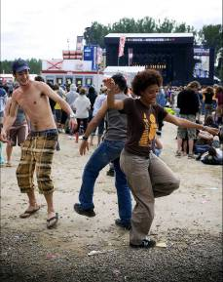

© Rob Walbers for Rock
Werchter

Local news

